Lab sheet 06

1.

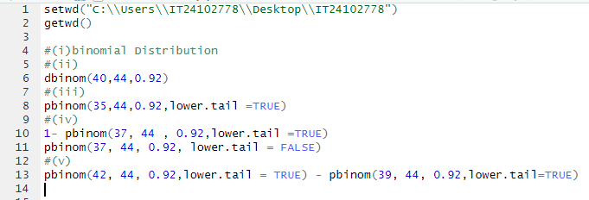



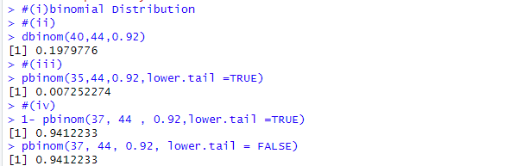



2.

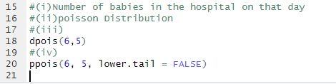

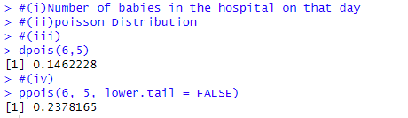

Exercise

1. lambda = 5

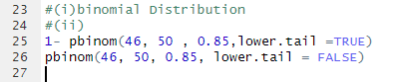

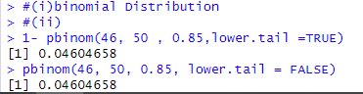

2. lambda =12

